**Power Bi Assignment**

**Comparison between stack and column chart:**

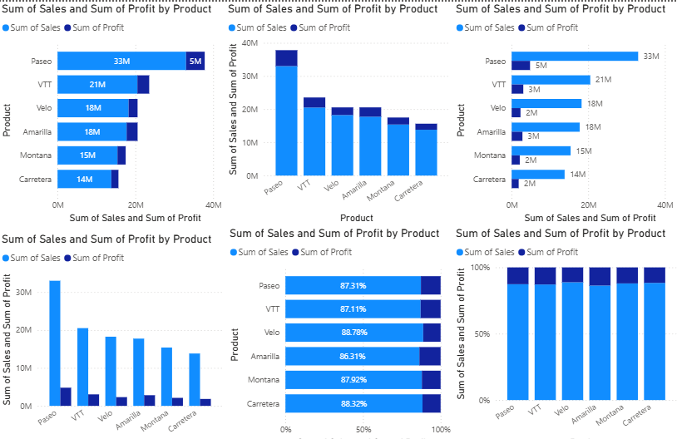

**Stacked Column Chart**

* Displays values for multiple categories stacked on top of each other in a single column.
* Use Case: Best when you want to show contribution to the total (part-to-whole analysis).

**Clustered Column Chart**

* Displays values for multiple categories side by side, with separate columns for each subcategory.
* Use Case: Best when you want to compare values across categories and subcategories independently.

**Creating a Stacked Column chart, Clustered Column Chart, Stacked Bar chart, Clustered Bar Chart:**

To create a **stacked Column chart**, **, Clustered Column Chart, Stacked Bar chart, Clustered Bar Chart:**

1. go to **Visualizations** and select the stacked column chart.
2. On the **Y-axis**, place the **Product** field.
3. On the **X-axis**, place the **Sales and Profit** field.
   * It will automatically change to **Sum of Sales and Sum of Profit**.

**Legend On**

**Data Labels On**

**100 % stacked bar chart and 100% stacked column chart:**

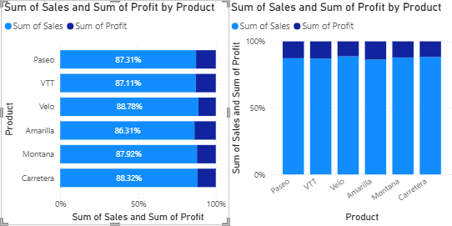

**100% Stacked Column Chart**

* Displays percentages of categories as vertical columns, where the total height of each column is 100%.
* Use Case: Best when you want to show percentage contribution over time (years, months, quarters) or across a sequential dimension.

**100% Stacked Bar Chart**

* Displays percentages of categories as horizontal bars, where the total width of each bar is 100%.
* Use Case: Best when comparing percentage contribution across categories with long labels (like product names, regions, or survey responses).

**Creating a Stacked Bar chart, Stacked Column chart:**

1. To create a **stacked bar chart**, **Stacked Column chart** go to **Visualizations** and select the stacked column chart.
2. On the **Y-axis**, place the **Product** field.
3. On the **X-axis**, place the **Sales and Profit** field.
   * It will automatically change to **Sum of Sales and Sum of Profit**.

Legend On

Data Labels On

**Conditional Formatting:**

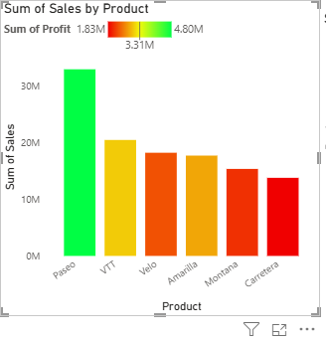

**Creating a Stacked Column chart:**

1. To create a **stacked Column chart**, go to **Visualizations** and select the stacked column chart.
2. On the **X-axis**, place the **Product** field.
3. On the **Y-axis**, place the **Sales** field.
   * It will automatically change to **Sum of Sales**.
4. Legend On

**Column → Color → Conditional Formatting**

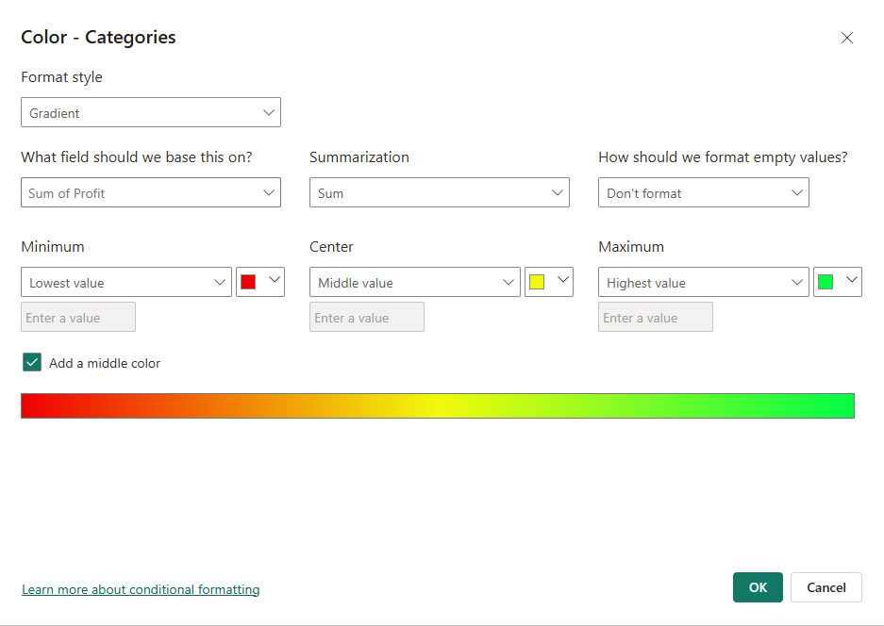

It uses a color gradient to represent the "Sum of Profit," with low values shown in red, middle values in yellow, and high values in green.

**Stacked Bar Chart:**

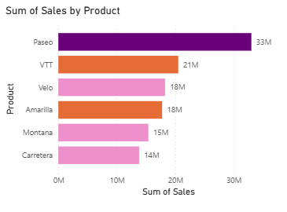

**Creating a Stacked Column chart:**

1. To create a **stacked Column chart**, go to **Visualizations** and select the stacked column chart.
2. On the **X-axis**, place the **Product** field.
3. On the **Y-axis**, place the **Sales** field.
   * It will automatically change to **Sum of Sales**.
4. Legend On

**Column → Color → Conditional Formatting**

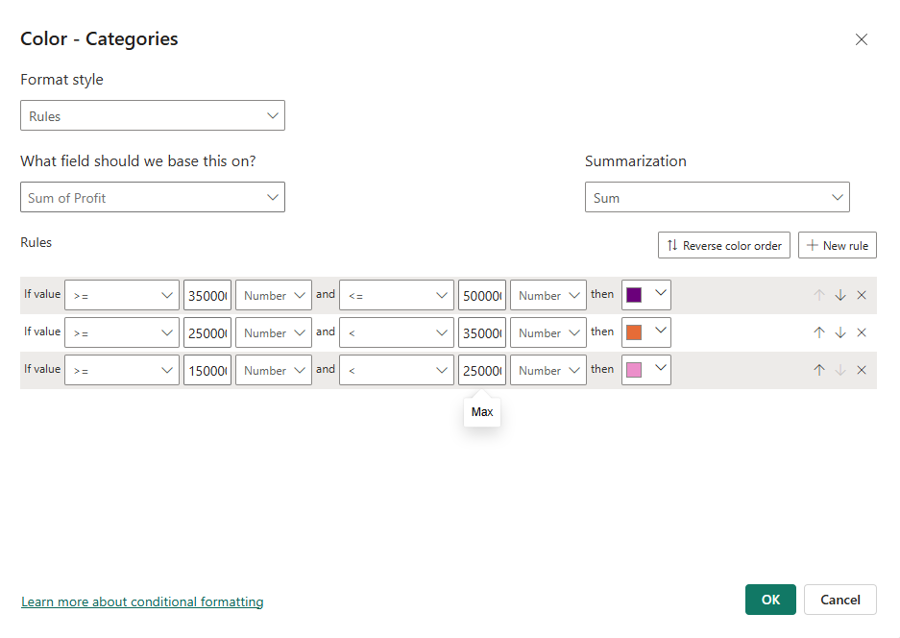

Conditional formatting using rules, where specific colors are applied based on a series of defined value ranges.

**Filter Condition:**

create a chart to represent product wise profit for each discount band

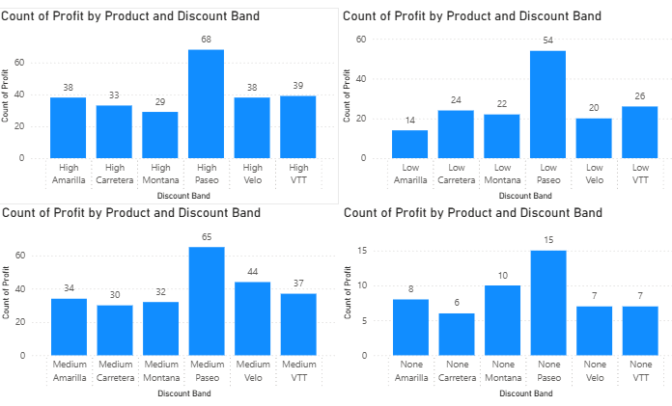

**Creating a Stacked Column chart:**

1. To create a **stacked Column chart**, go to **Visualizations** and select the stacked column chart.
2. On the **X-axis**, place the **Product and Discount Band** field.
3. On the **Y-axis**, place the **Profit** field.
   * We will change to **Count of Profit**.

"Filters" pane, with the visual filtered to only show data where the **"Discount Band" is "High** in first Stacked Column chart and **"Discount Band" is Low** in Second Stacked Column chart and **“Discount Band” is Medium** in third Stacked Column chart **“Discount Band” is None** in fourth Column chart.

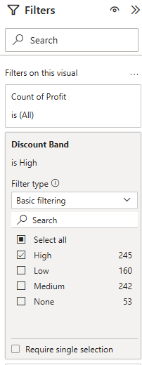

**Small Multiples:**

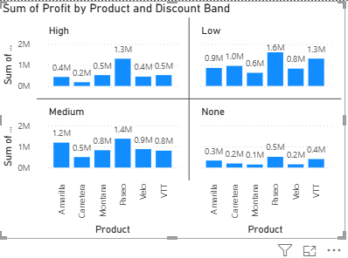

**Creating a Stacked Column chart:**

1. To create a **stacked Column chart**, go to **Visualizations** and select the stacked column chart.
2. On the **X-axis**, place the **Product** field.
3. On the **Y-axis**, place the **Profit** field.
   * We will change to **Sum of Profit**.
4. On the small Multiples place the Discount Band field.

**1. What is Power BI?** Power BI is a business analytics solution developed by Microsoft that helps you visualize data and share insights. It's an interactive data visualization software product with a primary focus on business intelligence.

**2. Who developed Power BI?** It was originally designed by Ron George in the summer of 2010 and named "Project Crescent." It was later renamed and unveiled by Microsoft in September 2013 as Power BI for Office 365.

**3. Why do we use Power BI?** Power BI is used to connect to various data sources, transform raw data, create interactive dashboards and reports, and share insights across an organization. It helps businesses and individuals make data-driven decisions.

**4. What are the main components of Power BI?** The main components of Power BI include Power BI Desktop, Power BI Service, and Power BI Mobile. Other key elements include Power Query (for data transformation), Power Pivot (for data modeling), and Power BI Gateway (for connecting to on-premises data).

**5. What is Power BI Desktop?** Power BI Desktop is a free, desktop application for Windows that allows users to connect to data, transform it, create data models, and build reports and dashboards. It's the primary tool for a report developer to create and author content.

**6. What is Power BI Service?** Power BI Service is the cloud-based platform where you can publish and share reports and dashboards. It is used for collaboration, distribution, and consumption of data visualizations.

**7. What is Power BI Mobile?** Power BI Mobile consists of a set of mobile apps for iOS and Android devices that allow users to view and interact with dashboards and reports on the go. You can't create or edit reports in the mobile app, but you can view real-time data and receive alerts.

**8. What is the difference between Power BI Desktop and Power BI Service?** Power BI Desktop is a free, local application used for creating reports and data models, whereas Power BI Service is a cloud-based platform for sharing, collaborating on, and viewing those reports and dashboards. The "heavy lifting" of data preparation and modeling is typically done in the Desktop version, while the Service is for distribution and consumption.

**9. What are the key features of Power BI?** Key features include: interactive data visualizations and dashboards, the ability to connect to hundreds of data sources, data transformation capabilities with Power Query, and seamless integration with other Microsoft products. It also offers real-time data updates, a natural language query feature (Q&A), and strong data security.

**10. What types of data sources can Power BI connect to?** Power BI can connect to a wide range of data sources, including local files (like Excel and CSV), databases (like SQL Server and Oracle), cloud services (like Azure and Salesforce), and many other online services.

**11. What is a visualization in Power BI?** In Power BI, a visualization, or "visual," is an image created from data to help users understand it. Examples include bar charts, line graphs, pie charts, maps, and KPIs (Key Performance Indicators).